Software System Design
Document Specification

Apartment Rental System
Fall 2015

By
Faheem Syed

Table of Contents

Introduction 3
Application Architecture 5
System Functions 6
User Interface 7
Components 10
Database 11
Required Hardware and Software 12
Appendix A 14

Table of Figures

Figure 1. Application Architecture 5
Figure 2. User Interface 5
Figure 3. 6
Figure 4. 12

1. Introduction
This is a basic system that will keep a record of apartments available for rent in the New York City area, the system will work as a connecting bridge between customers and property sellers. This system will ease the search for apartments for potential buyers as well as provide property owners with a larger audience than traditional methods. It will minimize apartment search and sell times for customers and sellers respectively.
More specifically, the Apartment Rental System is designed to allow buyers to see potential homes in much more detail than contacting sellers and seeing apartments in person. It will also allow sellers to post their apartments with minimal effort and cost to them as well as be contacted through email and telephone.
2. Application Architecture
Describe application components, structures and interconnections. Provide information for major component functions and major technologies used on the application.
3. Required System Functions
- account. First name, last name, email, and phone number will be required to sign up.
- Log in/Log out: The system will allow returning users to log in. This will give buyers access to listings and sellers will get the ability to post new, update or delete listings.
- Search Listings: The system will allow the user to view listings of apartments for rent.
- Rent: The system will provide the sellers contact information for renting an apartment
- Update Listings: The system will allow sellers to add, edit/update or delete their listings.
4. User Interface
User log in-> system check if exist-> if yes go to the next page-> error message
User sign up-> system save user info-> user logged in-> search page-> user search by location, price, # of bedrooms or # of bathrooms-> results page-> user chooses one of the option and press “rent this apartment”-> appointment page-> user send message to owner and press send-> user log out.
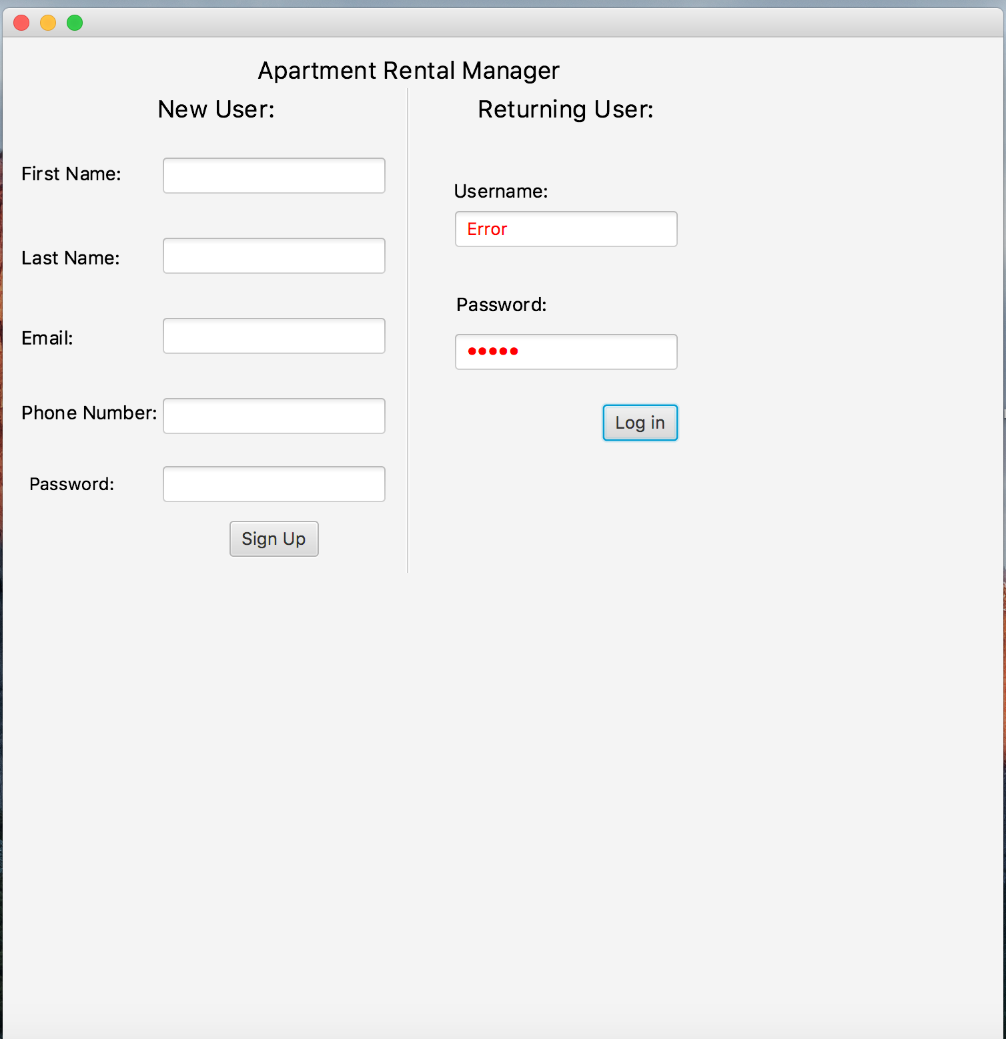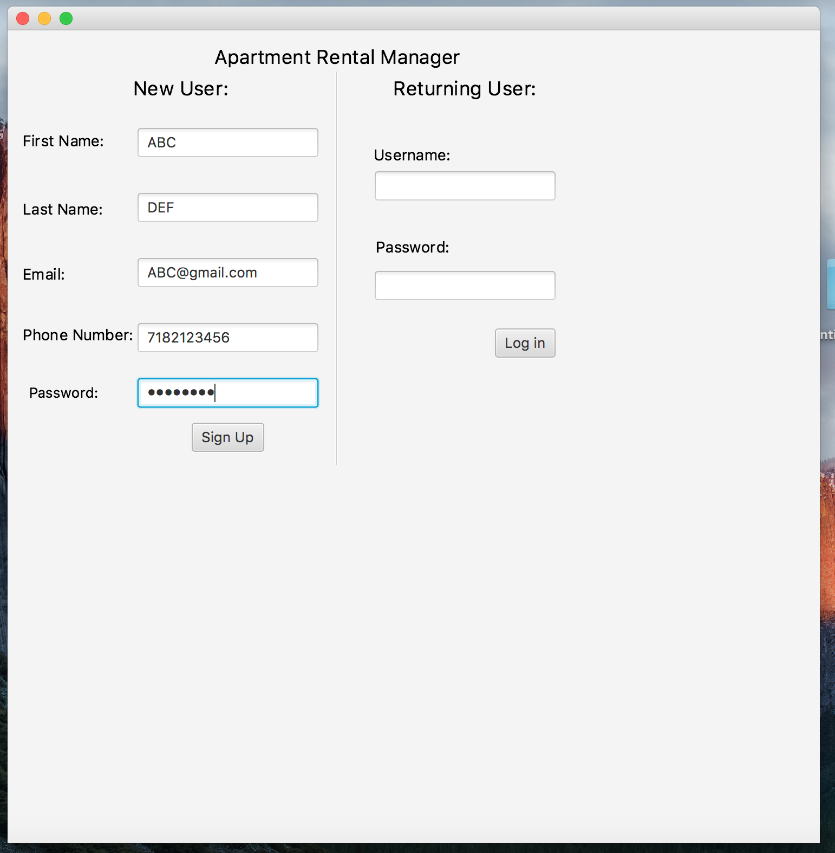
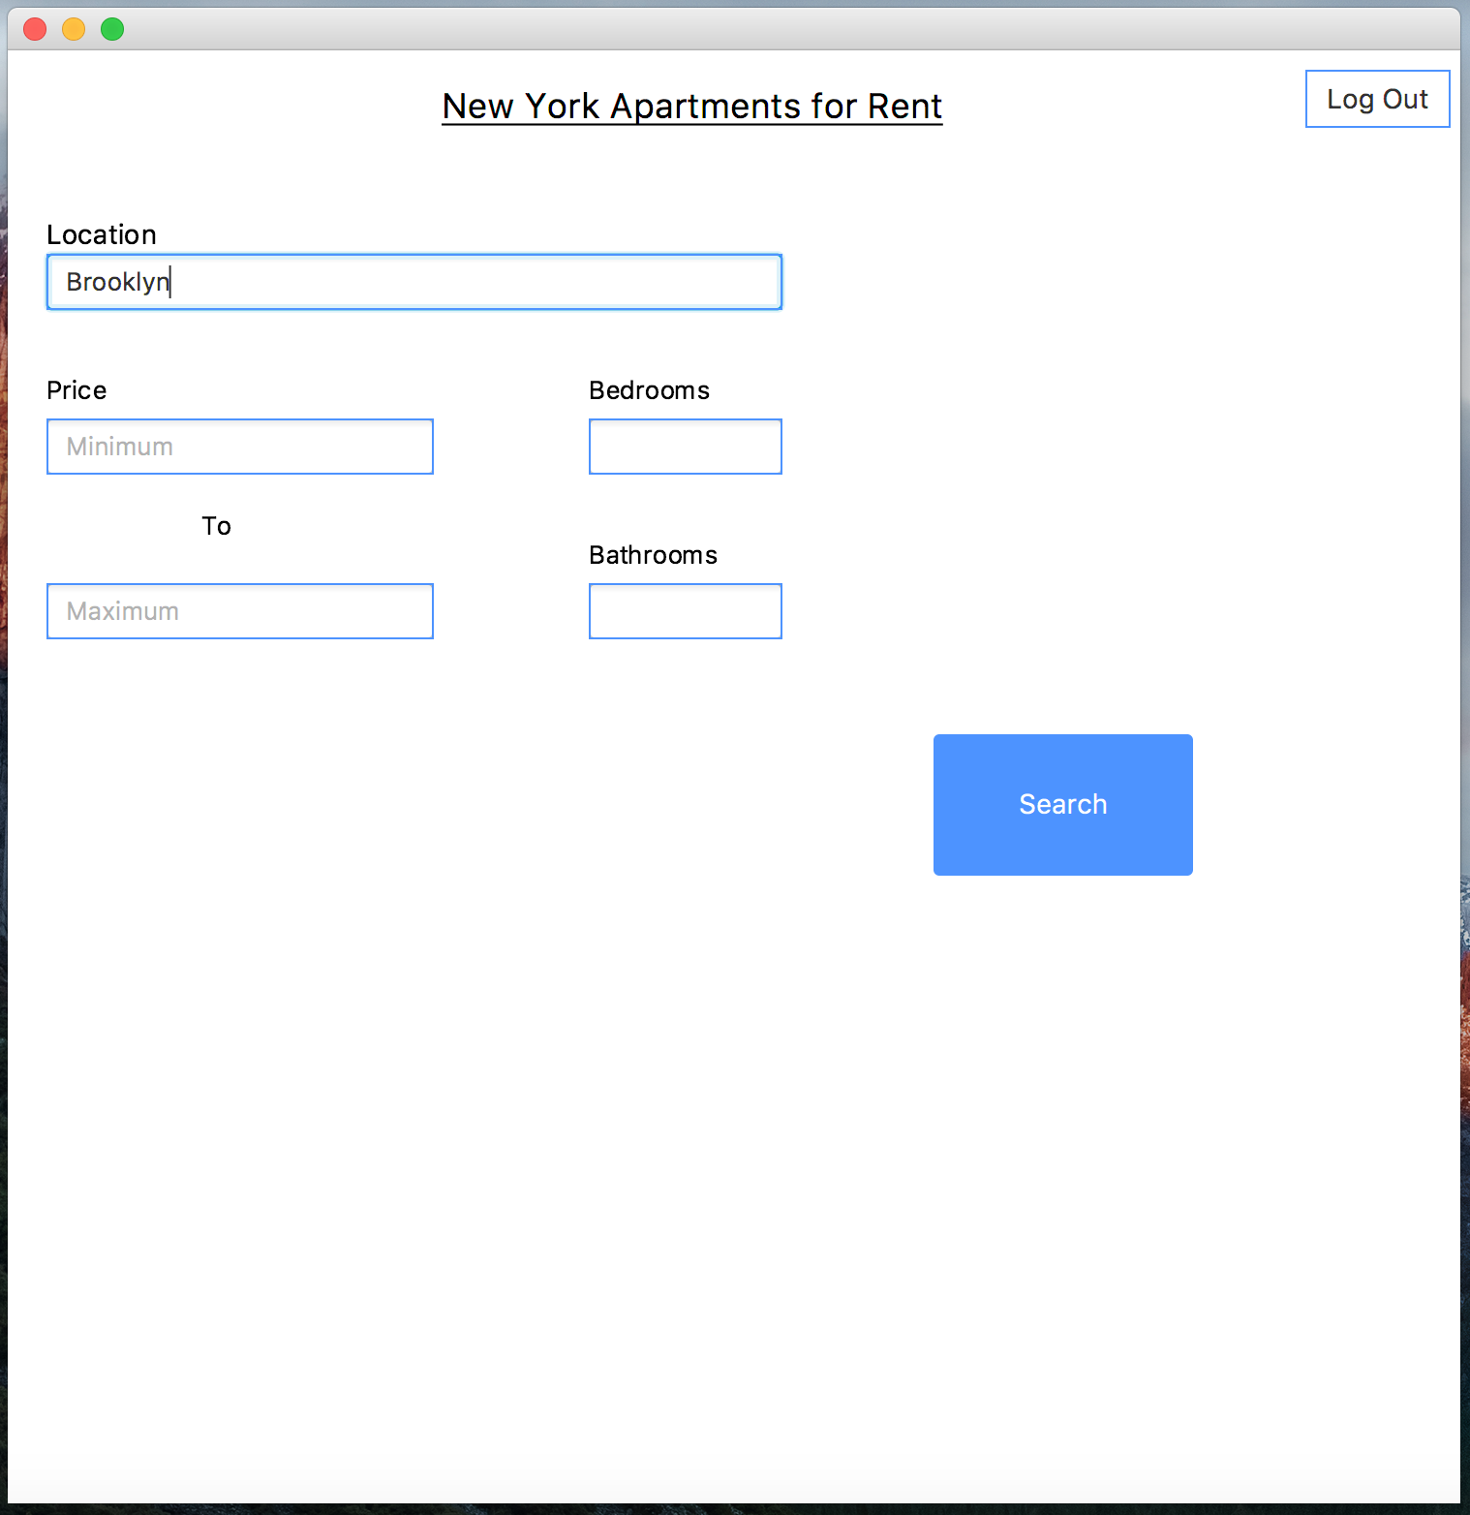
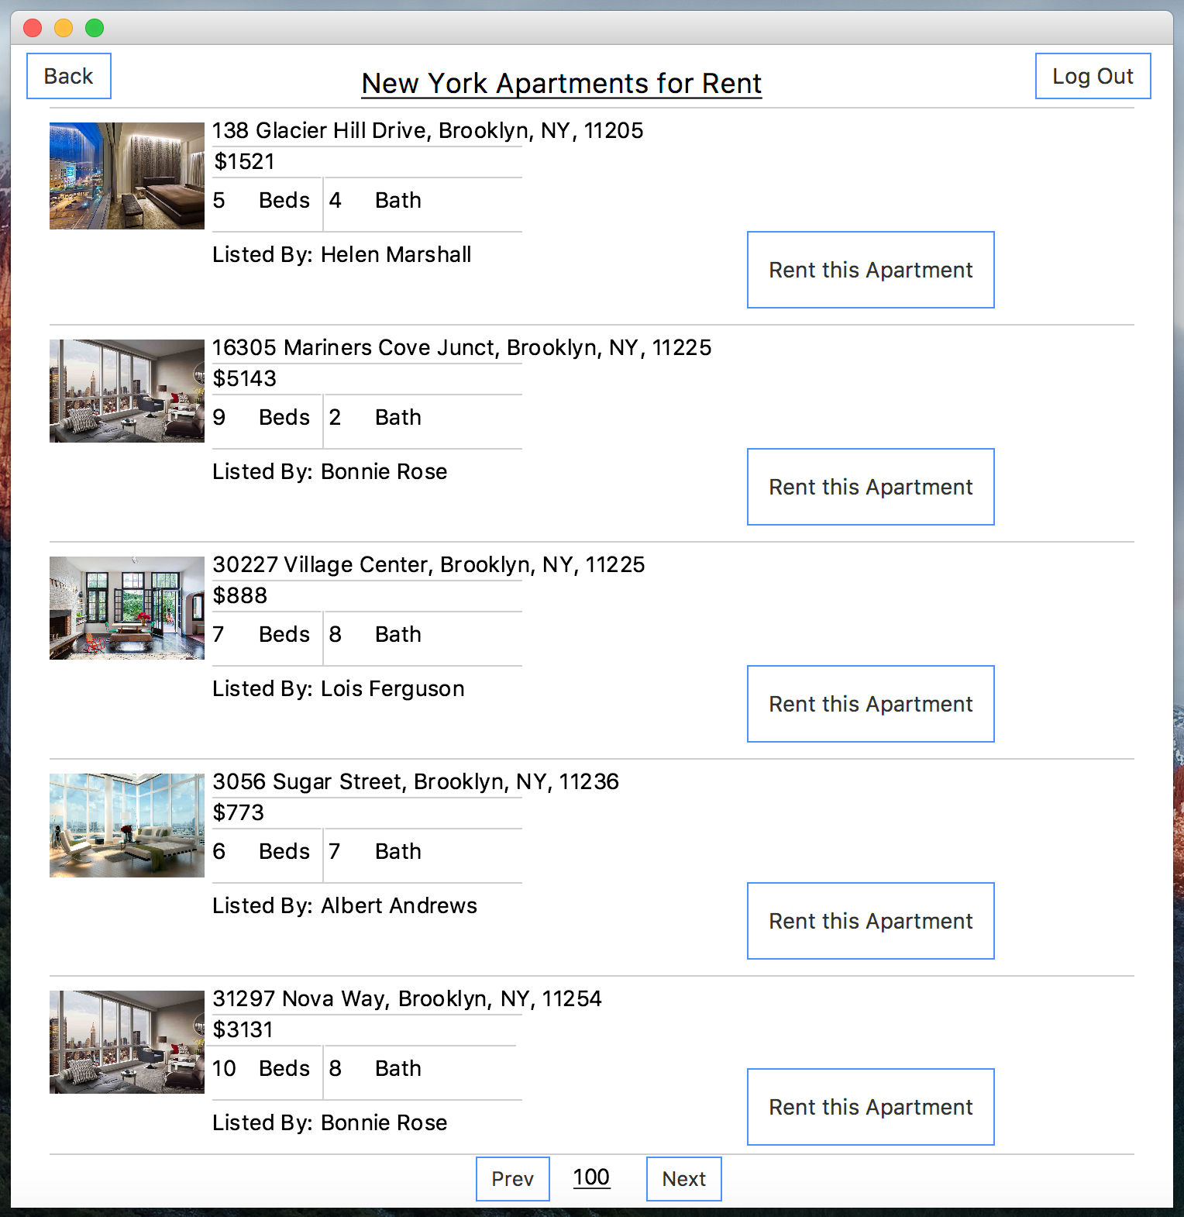
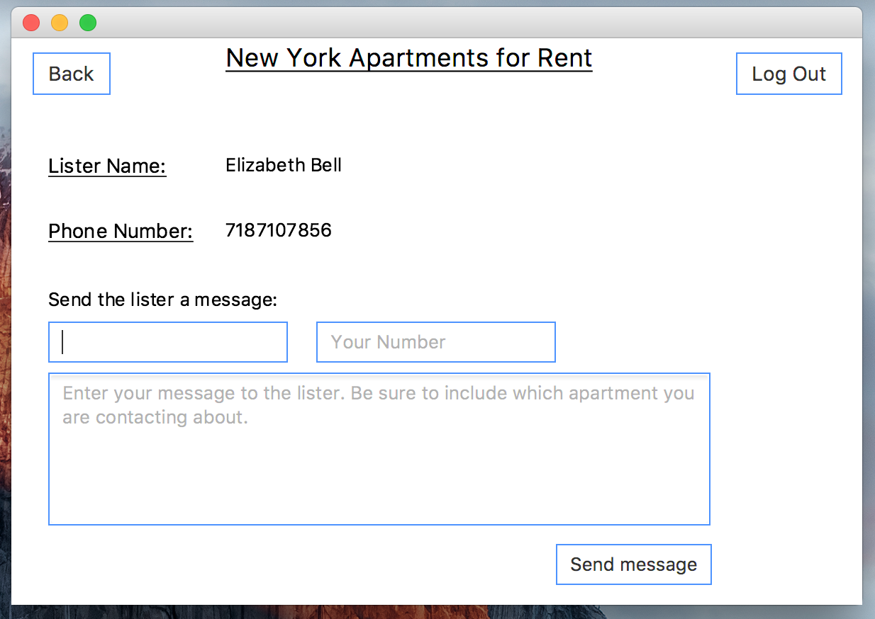

5. System Components
List of system components or modules, their functions and how they interact with each other.
Name | Function Description | Input Data | Output Data | Dependencies
6. Database
Apartments table
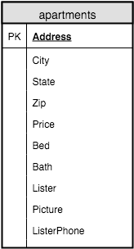
Users table
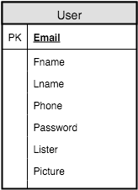

7. Required Software and Hardware
Windows or OSX device.

